2022 Virtual Bishop’s Fishing Tournament Rules
- Register to participate on our website: www.ccfesd.org or by calling our office 605-988-3765.
- Once you’ve registered, you will receive an email from events@ccfesd.org with a special coupon code to access our virtual tournament (this will come one week prior to the start of the tournament).
- All members of the team must be registered with our office.
- Download the official app – iAngler Tournament. This is a free app and can be found in the App Store or Google Play Store.
- The tournament begins on Saturday, June 4th at 7:00 AM and will end on Monday June 13th at 2:00 PM.
- The tournament will run for 10 consecutive days and you can fish any one day or all ten days with no restrictions.
- You may fish from shore or boat on any public body of water within the state of South Dakota. No private waters fishing.
- This is considered a team tournament.
  - Teams can consist of up to 4 people.
  - Teams may fish together or from different locations and even on different days.
  - iAngler will combine your catches automatically on the leaderboard.
  - KC Challenge Teams must include two of the following: Knights of Columbus member, Priest, youth, or Honorary Knight.
- There will be two divisions – Walleye or Bass – that will count toward your team’s total length for 6 fish.
  - Only one prize will be awarded per team, either for the walleye division or the bass division. You cannot participate in both divisions in the virtual tournament.
  - The species you choose to submit for judging will automatically place you in that division.
  - This is a voluntary catch/keep or catch/release tournament. You are responsible for any fish you keep.
- You must follow the South Dakota Game and Fish rules and regulations.
- To submit your catch to the tournament, use the iAngler Tournament app. Catches will be judged by our official judging committee.
  - Minimum accepted length for tournament entry will be 15 inches for walleye and 12 inches for bass. Please do not submit any fish caught that fall under these size requirements
  - Each catch entered into the tournament must have two photos:
    - A photo of your catch being measured using a bump board or ruler/measuring tape. The nose should be butted up against the end and the tail squeezed to reach maximum length when the photo is taken.
    - A photo of the individual who caught the fish, holding the fish!
  - If you do not have service at the time of your catch, you can take the photo of the fish, log the information needed and click “hold”. This will save your fish and details until you have an internet connection to submit the catch.
- This is an “honor system” tournament. The object of the tournament is to have an enjoyable fishing experience with family and friends in support of our seminarians and Bishop DeGrood.
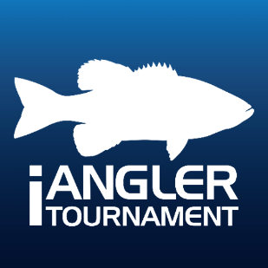
- Awards will be given for:
  - Team Longest Walleye - Top 3 teams (total length of 6 fish)
  - Team Longest Bass – Top 3 teams (total length of 6 fish)
  - Adult Longest Walleye (one overall winner)
  - Adult Longest Bass (one overall winner)
  - Youth Longest Walleye (one overall winner)
  - Youth Longest Bass (one overall winner)
  - KC Challenge Cup (KC Challenge team with most total length)
- Check your email daily for tournament updates!

